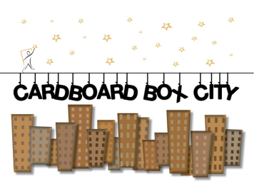
Registration & Release for Adult Participation
(Every CBC “renter” 18 and over must have this form filled out.)
Cardboard Box City—September 24-25, 2016
Name:________________________________________________ Age___________ Birthdate____________ Male___ Female____ Email_________________________________________ Address________________________________________________________ Zip ______________ Home___________________ Work __________________ Cell __________________ Emergency contact____________________________ Telephone ___________________ Medical Insurance Company_________________________________ Policy#_______________________
Do you have allergies to: ___ Pollens ____ Medications ____ Food ____Insect bites
Do you suffer from or have ever experienced, or are being treated currently for any of the following: ___ Asthma ___Diabetes ___Heart trouble ___Epilepsy/seizure Disorder Other__________________ Date of last tetanus shot _____________
The undersigned__________________________(name of participant), hereby represents that he or she is, in fact, acting as such capacity and AGREES TO DEFEND, HOLD HARMLESS, AND INDEMNIFY FAMILY PROMISE AND ANY OF ITS OFFICERS, AGENTS,SERVANTS,OR EMPLOYEES FROM ALL LIABILITY, LOSS OR HARM THAT MAY OCCUR BY REASON OF THEIR PARTICIPATION IN THE CARDBOARD BOX EVENT. BY MY SIGNATURE BELOW, I ACKNOWLEDGE AND AGREE TO THE ABOVE, THE WAIVER AND RELEASE SIGNED BY THE ABOVE PARTICIPANT, AND TO PERMISSION FOR MEDICAL ATTENTION SET FORTH BELOW. I further give Family Promise permission to seek whatever medical attention is deemed necessary, and release Family Promise of any liability against personal losses of the above participant. I also acknowledge that I will be ultimately responsible for the cost of any medical care should the cost of that medical care not be reimbursed by the health insurance provider.
___ I hereby GRANT permission to Family Promise, the right, without fee, to make, edit, use or display photos and audio/DVD recording (images) of me/my child.
___ I DO NOT GRANT permission to Family Promise to use my image for news or publicity purposes.
PARTICIPANT SIGNATURE_______________________________________________Date__________________

Please mail or bring this form with $25.00 rent(registration fee) and sponsor sheet to the following address before 09/02/15. After this date the registration will be $30.00. Thank you for your participation!
Family Promise, 1022 W Darlington St. Florence, SC 29501

